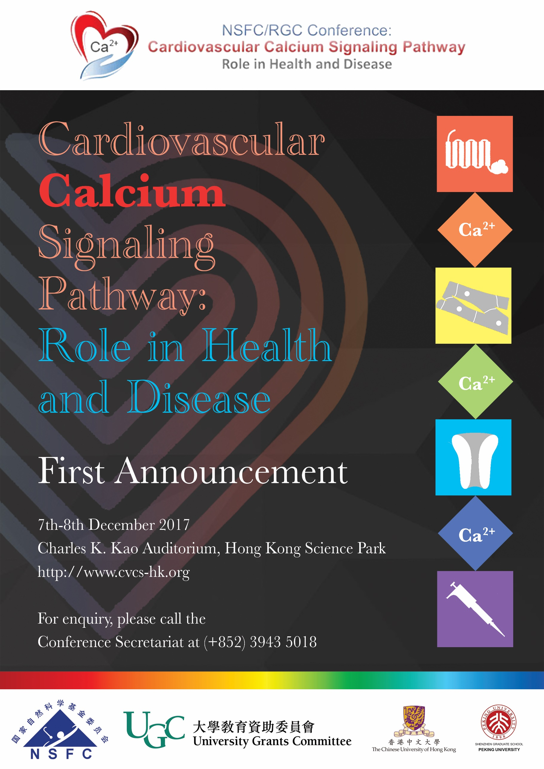

**Invitation**

**The NSFC/RGC Conference:** **Cardiovascular Calcium Signaling Pathway, Role in Health and Disease** will be held on **7th-8th December 2017** in the **Charles K. Kao Auditorium, Hong Kong Science Park, Shatin**. The conference is co-organized by the School of Life Sciences, School of Biomedical Sciences, Department of Medicine and Therapeutics, La Ka Shing Institute of Health Sciences, Institute of Vascular Medicine, The Chinese University of Hong Kong (CUHK) and Peking University Shenzhen Graduate School (PKUSZ).

Cardiovascular diseases (CVD) remain a major cause of mortality and morbidity world-wide and in Hong Kong. The CVD prevalence has been increasing due to an ageing population and an increasing level of obesity and diabetes. Calcium signaling plays critical roles in cellular function and is important for life. Calcium ions (Ca2+) are the most versatile second messengers as many vital physiological processes within the body are controlled by intracellular free Ca2+. Ca2+ enters the cell through Ca2+ channels that may be voltage-operated, ligand-operated or mechanically operated. Ca2+ can also be released from intracellular compartments by second messengers, such as inositol triphosphate (IP3). Indeed, most intracellular Ca2+ is stored in the endoplasmic reticulum and release of Ca2+ into the cytosol creates a Ca2+ signal, or Ca2+ “spark”, that can be recorded by using state-of-the-art Ca2+-imaging techniques.

This conference will bring together researchers and clinician scientists in the field of in calcium signaling and cardiovascular health and disease from Mainland China and Hong Kong with the primary goal of enhancing our understanding of the underlying mechanisms of Ca2+ signaling in cardiovascular health and diseases. We hope to establish some new or longer-term research collaboration between Hong Kong and Mainland researchers.

We are delighted to your participation in this exciting conference.

Organizing Committee:

*Prof. Jack Wong,*

School of Life Sciences, CUHK

*Prof. Gary Tse,*

Faculty of Medicine, CUHK

*Prof. Kunfu Ouyang,*

Peking University Shenzhen Graduate School

Meeting information

**Date:**

7th-8th December, 2017 (Thurs & Fri) from 9:00 am – 6:00 pm

**Venue:**

Charles K. Kao Auditorium, Hong Kong Science Park, Shatin

**Official Language:**

English

**CME accreditation will be applied:**

Under application

**Young Investigator Awards:**

Applicants who are students or scientists within five years of receiving master/doctoral degrees are welcome to participate in the Young Investigators’ Competition.

**Outstanding Poster Presentation Awards**

The prize is given for the three best presentations.

The main criteria are the scientific quality and originality of the research, plus the quality of the presentation.

**Registration & Registration fee:**

It will be available through our official website.

<http://www.cvcs-hk.org>

Invited Speakers and Abstract Presenters are free

Students: HK$50

Other participants: HK$200

**Further information & contacts:**

Dr. Christina Leung, Conference Secretariat,

Room 505, Mong Man Wai Building, School of Life Sciences, Chinese University of Hong Kong

Email: christina_leungfp@cuhk.edu.hk

Phone: (852) 3943 5018

Fax: (852) 2603 7732

Meeting information

**Date:**

7th-8th December, 2017 (Thurs & Fri) 9:00 am - 6:00 pm

**Venue:**

Charles K. Kao Auditorium, Hong Kong Science Park, Shatin

**Official Language:**

English

**CME accreditation will be applied:**

Under application

**Young Investigator Awards:**

Applicants who are students or scientists within five years of receiving master/doctoral degrees are welcome to participate in the Young Investigators’ Competition.

**Outstanding Poster Presentation Awards**

The prize is given for the three best presentations.

The main criteria are the scientific quality and originality of the research, plus the quality of the presentation.

**Registration & Registration fee:**

It will be available through our official website.

<http://www.cvcs-hk.org>

Invited Speakers and Abstract Presenters are free

Students: HK$50

Other participants: HK$200

**Further information & contacts:**

Dr. Christina Leung, Conference Secretariat,

Room 505, Mong Man Wai Building, School of Life Sciences, Chinese University of Hong Kong

Email: christina_leungfp@cuhk.edu.hk

Phone: (852) 3943 5018 Fax: (852) 2603 7732